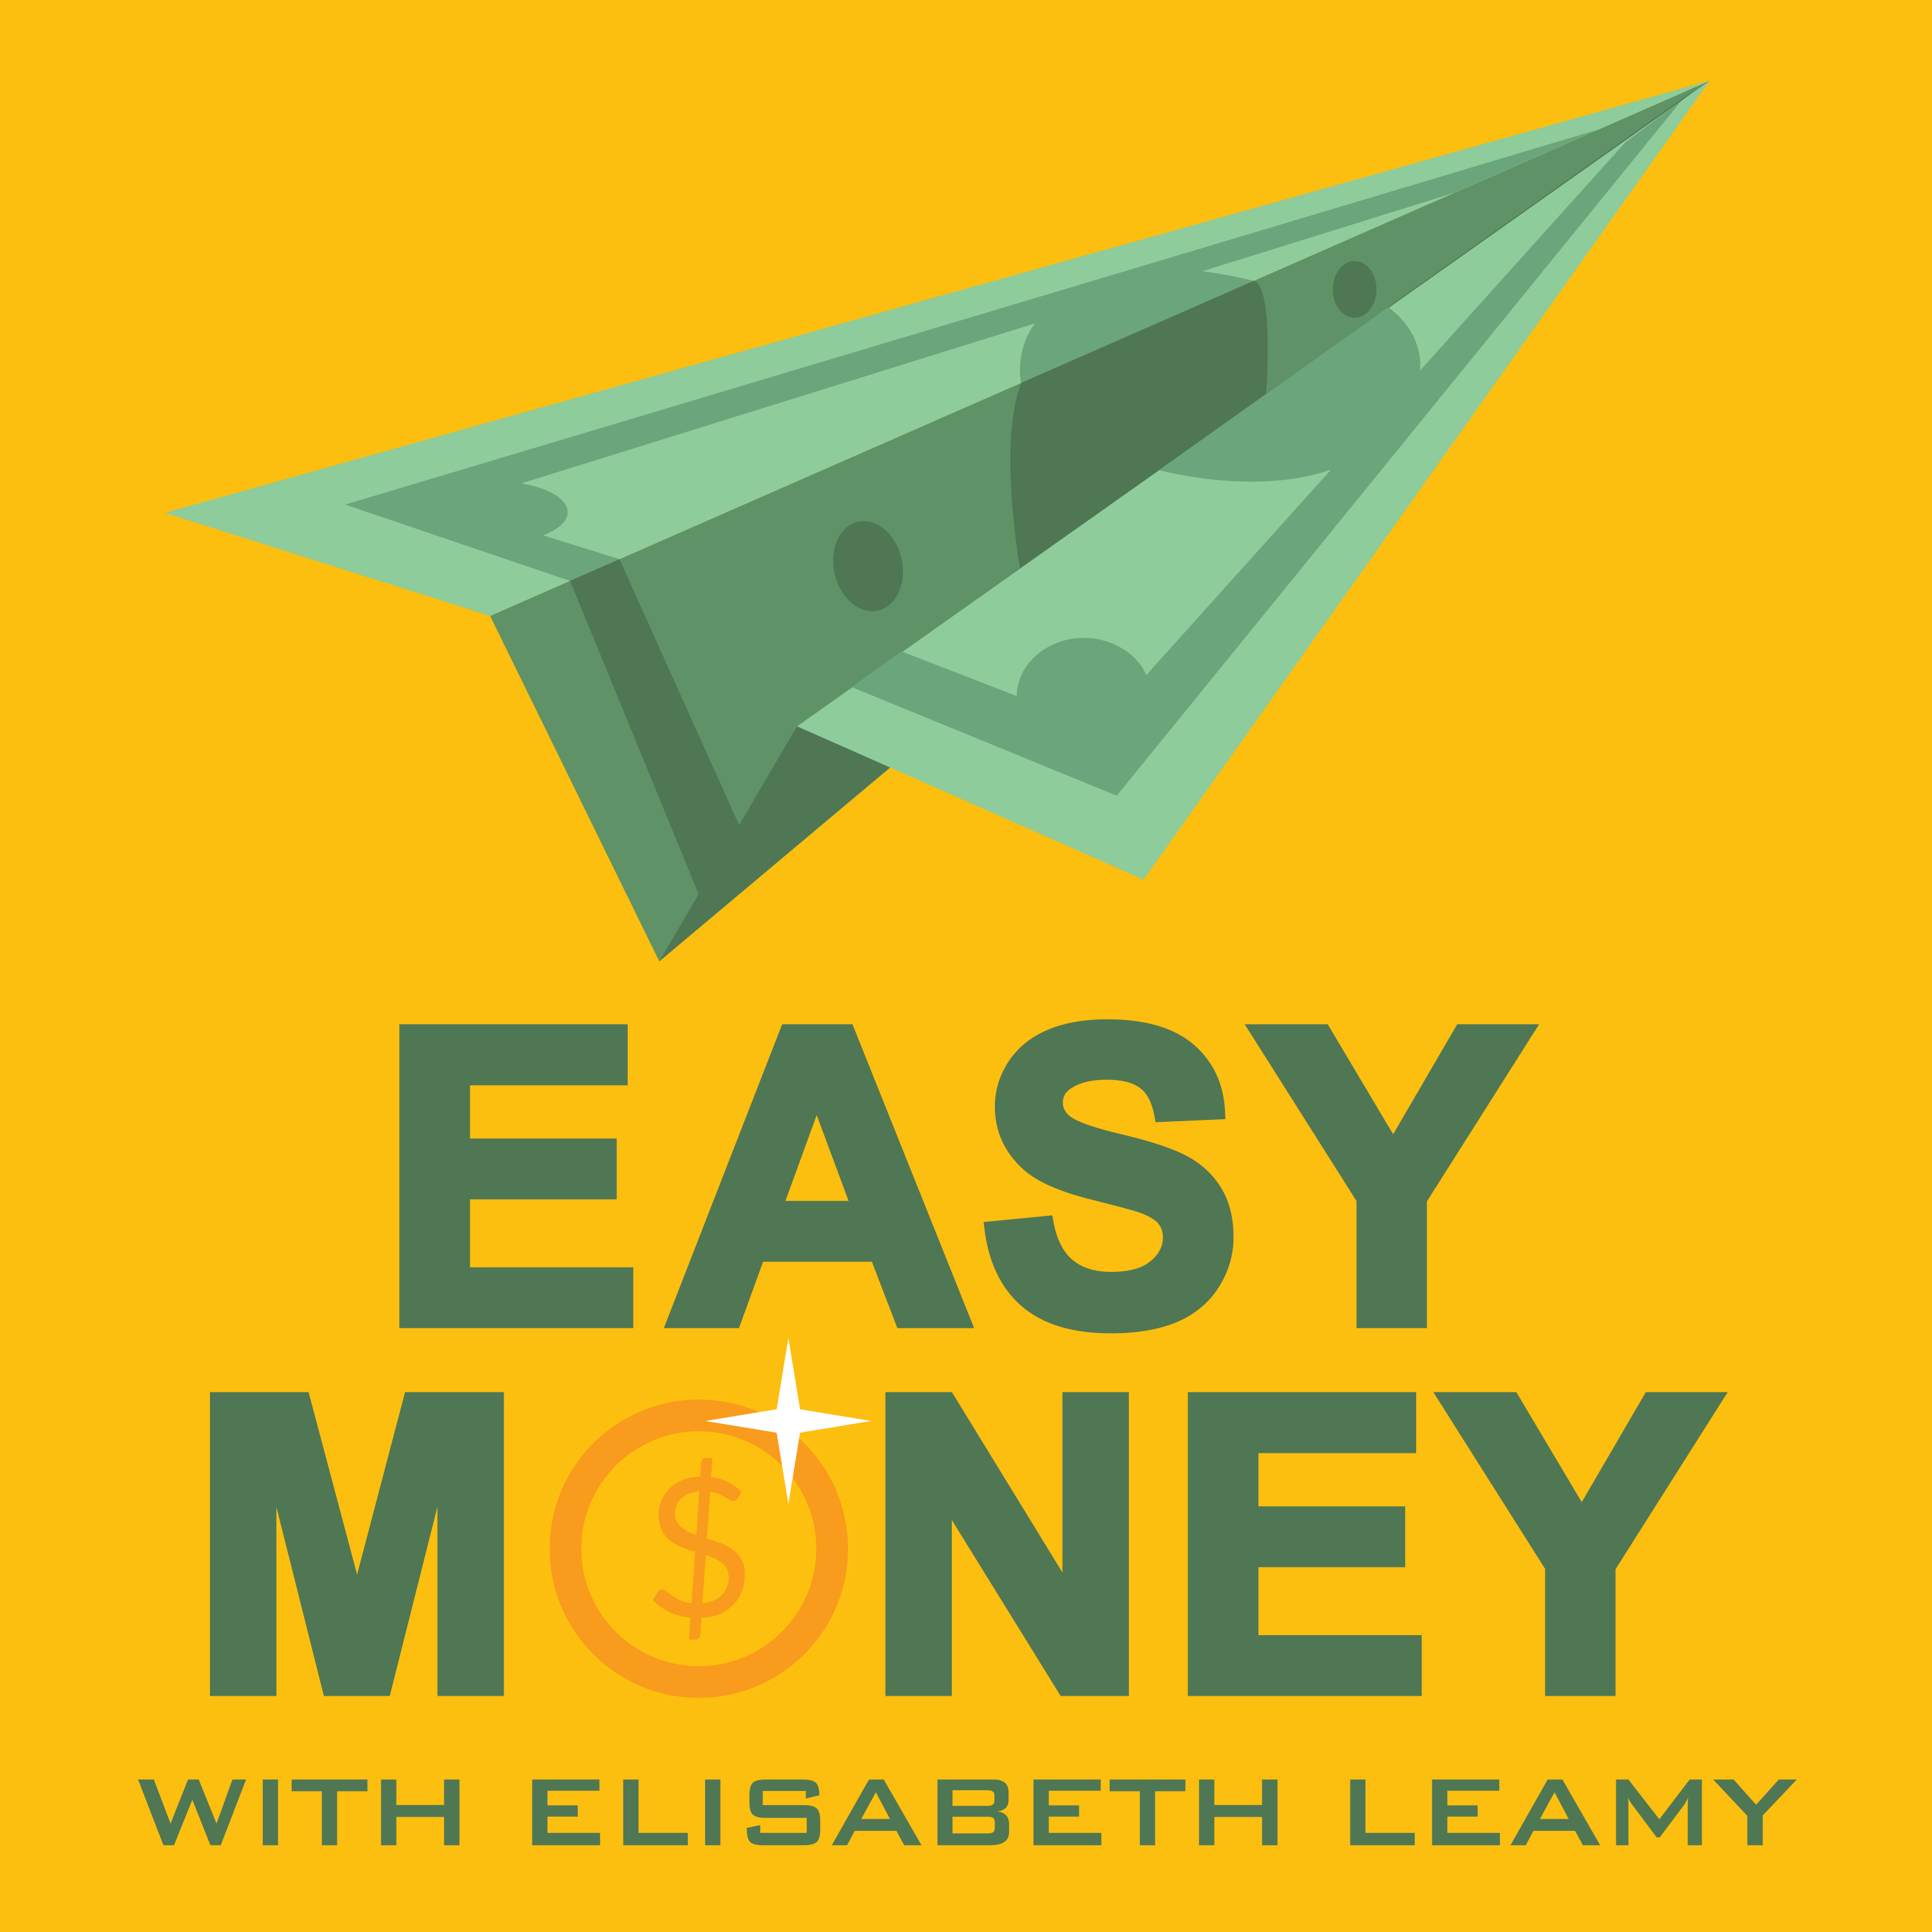
For Immediate Release Contact: Elisabeth Leamy (202) 276-7444
Elisabeth@ElisabethLeamy.com

Missing Money: How To Find Unclaimed Money
Award-winning Print and Broadcast Journalist Elisabeth Leamy Helps Listeners Find Their Share of $42 Billion in Unclaimed Property on Her Podcast “Easy Money”

WASHINGTON, D.C., November, 2017 – With just two websites and ten minutes you can find out if there is unclaimed money waiting for you. The 50 states plus the District of Columbia are holding at least $42 billion worth of this missing money for their citizens. Roughly 1 out of every 10 of us has unclaimed money out there. The money comes from things like tax refunds that were mis-routed, stock dividends you never cashed, utility deposits that weren’t returned to you, and life insurance policies set up by deceased relatives. The average claim is $892, according to the National Association of Unclaimed Property Administrators.

Spencer Hathaway of Washington, DC found accounts in three different jurisdictions: un-cashed health insurance refunds in the District of Columbia and life insurance dividends in both California and Iowa. Hathaway learned how to find unclaimed money from Elisabeth Leamy, host of the Easy Money podcast, which covers one unclaimed money topic each week. “Part of the fun of this is that you go back and revisit parts of your life that you don't think about,” said Hathaway. “I feel like this money’s just rolling in like manna from heaven or something.” Hathaway was able to recover nearly $2,000 worth of missing money.

So how do you search? It’s simple —and free. First go to MissingMoney.com, fill in your first and last name, and then enter your state of residence. The site will automatically check all 40 of its state partners. So with a single search you have covered the majority of states.

There are ten states that don’t participate with MissingMoney: Arkansas, California, Connecticut, Delaware, Georgia, Hawaii, Illinois, Oregon, South Carolina and Wyoming. If you have lived, worked, or done business with a company in any of those states, you should search them individually. To do that, head to another free website, Unclaimed.org. (Important note: the free website ends in “.org.” —not .com.) Click on the state you want to search and you will be re-routed to its own unclaimed property page.

If you find an unclaimed money account in your name, claiming it is fairly easy. You may be asked to provide proof that you did business at the bank in question or lived at the address listed. One easy way to gather that proof is to pull your own free credit report at AnnualCreditReport.com. Credit reports typically list old accounts and addresses. Some states also ask you to have your application form notarized. “I was pleasantly surprised,” said Hathaway. “It wasn’t difficult. I just had to do a little bit of paperwork and copy some documents.”

13-time Emmy-winner Elisabeth Leamy started covering unclaimed money when she was the consumer correspondent at Good Morning America. “After my first unclaimed money story, our viewers nearly crashed the ABC News server,” said Leamy. “That’s when we knew we had hit on a hot topic that people didn’t know much about .” Leamy has helped reunite people with nearly $2 million worth of unclaimed money, first at GMA and now on her podcast.

A third of every Easy Money podcast episode is devoted to unclaimed money —and so far there’s no shortage of topics. Leamy talks about how to find unclaimed money held by the feds —like lost savings bonds, pensions and tax refunds. She tells listeners why it’s urgent to claim the contents of forgotten safe deposit boxes as soon as possible. She looks for unclaimed money for small businesses, churches, charities and schools. And she talks about how to tap into unclaimed money held by courts, such as unpaid child support. There are even advanced strategies for finding your missing money if you don’t succeed with the two free websites above. “This is your money, not the state’s money,” said Leamy. “I just want people to claim what’s rightfully theirs.”

NEED TO ADD THIS TO PRWEB RELEASE!!!
About The Easy Money Podcast and Host Elisabeth Leamy:
Every week on Easy Money, 13-Time Emmy-winner Elisabeth Leamy (Washington Post, Good Morning America, Dr. Oz) uncovers clever, creative ways to make more money, save more money and find your unclaimed money. Her goal is to make understanding money easy —not hard. By utilizing this story idea, you will be getting quality FREE content, while helping an ad-free, educational podcast. Download all story materials at: EasyMoneyShow.com/press-kit.

Easy Money Podcast Links: (Please include these links on your website in exchange for use)
Easy Money on iTunes: http://apple.co/2tpUY6v
The Easy Money Show website: EasyMoneyShow.com

##

TAGS: Missing Money, Unclaimed Money, Unclaimed Property

